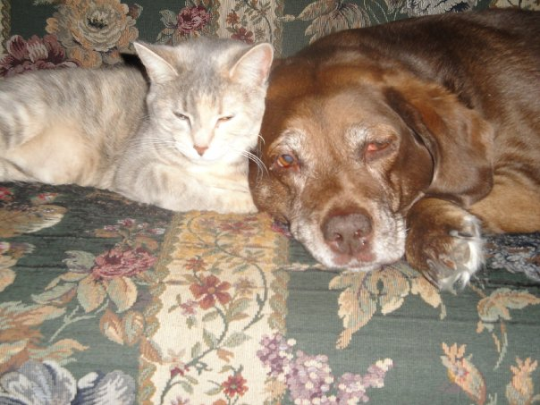

For owners and veterinarians, euthanizing a pet is one of the most difficult things you will ever do. Whether your pet is suffering from old age or a disease/illness this decision is something that you and your family will make together with the support of your veterinarian. As hard as this decision is remember that it is the best gift we can give our pets in helping them through this peaceful journey.

Along with this decision comes many questions. Our staff is here to help you through this difficult time. Please click on any of the following frequently asked questions for more information.

**How do I setup the appointment?**

**What happens during the appointment?**

**What actually happens when my pet is put to sleep?**

**Will the procedure be painful for my pet?**

**What are my options for aftercare?**

**I am having a difficult time grieving my loss. What support resources are there?**

**How do I setup the appointment?**

To set up an appointment time please call the hospital when you are ready. If you would like a specific doctor to perform the procedure please let us know during the phone call. We recommend that the appointment be either first or last of the day so the hospital is not overly busy for more privacy. We also have a separate comfort room and entrance which we have decorated to have more of a home feeling with a couch and soft music playing.

**What happens during the appointment?**

When you come in for your appointment we will ask you to read and sign a consent form, confirm aftercare requests and will take payment. Once completed we will guide you, your pet and any additional friends or family into our comfort room area where we encourage you get as comfortable as you like. Either the doctor or technician will then come in to sedate your pet (an injection under the skin). This takes about 15 minutes where ideally your pet will become more relaxed and subdued From there the doctor and technician will place an intravenous catheter into one of your pet’s leg vein prior to the injection being given. You are welcome to stay with your pet as long as you need to after the procedure is complete.

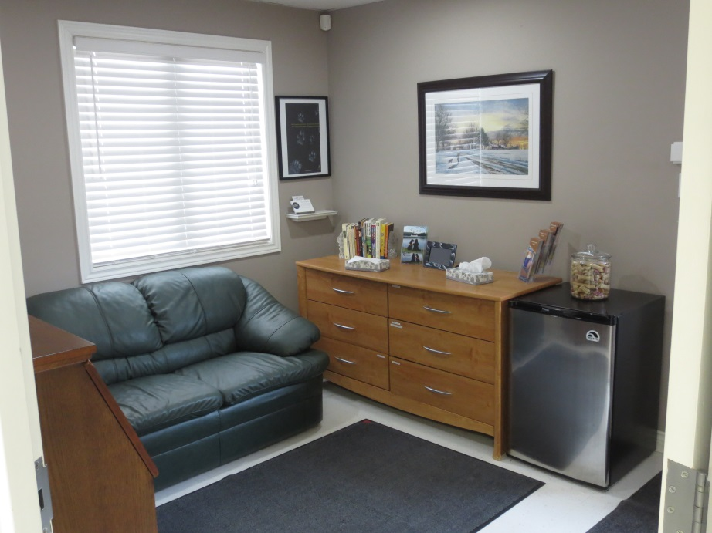

**What actually happens when my pet is put to sleep?**

***The following describes the euthanasia procedure. If you do not wish to read about this please leave this page now.***

The procedure is performed by the veterinarian. We will sedate your pet which is an injection that will go under the skin like a vaccine. This allows your pet to be able to relax and become a little sleepy before the injection. Often times is takes about 15 minutes for it to be effective. An IV catheter is then placed in one of your pet's leg veins, and an intravenous injection of a concentrated anesthetic is given (acts as an overdose). In general it is very rapid and very peaceful. Your pet will just go to sleep. On rare occasions their may be a brief vocalization or cry as consciousness is lost. This is not a cry of pain although you may misinterpret it as such. If your pet has poor circulation or low blood pressure, it may also take a few moments longer for the injection to work.

Within seconds of starting the injection the overdose will cause the heart to stop and any circulation within the body will stop. As the heart stops and the blood pressure decreases the animal will stop breathing and your pet will die peacefully.

Once your pet has died you may observe some involuntary muscle contractions or respiratory gasps – again this is not evidence of pain or consciousness.  The bladder and/or bowel may empty in the absence of muscle tone.

**Will the procedure be painful for my pet?**

Simply, no.  Your pet may feel a small sting when the sedative is given and they may also feel the poke of the catheter being advanced.  We try to keep your pet as comfortable as we possibly can and we hope that it is a peaceful journey for your pet.  If at any time during the procedure you feel uncomfortable or have a question please do not hesitate to let us know.



**What are my options for aftercare?**

You have several options for the aftercare of your pet. You may choose to take your pet home for burial, segregated cremation, communal cremation, or private cremation. We also offer ink paw prints and hair clippings at no cost. We may also obtain a pawprint mold for you where you can then get it finished through PearTree Impressions for a fee. Visit this website for more information: http://www.peartreeimpressions.com/

We use Veterinary Referral Cremation Services (VRCS) for our cremation services. For more information on their company please visit their webpage http://vrcs.ca/

If you choose **communal cremation** your pet is handles with dignity and respect and is cremated with other beloved ones. Your companion’s cremains are scattered on their Pathway to Life Walkway overlooking the beautiful Ottawa River.

If you choose **segregated cremation** your cherished pet is carefully placed in an individual section in a shared crematory to ensure his/her complete coming home to you. A signed certificate and engraved identification tag accompanies him/her home in your choice of one of their standard urns.

If you choose **private cremation** your faithful companion is the sole pet tenderly placed in the crematory, ensuring that the ashes of your treasured family member is returned to you. His/her ashes are safely placed in your choice of one of their standard urns. A signed certificate and engraved identification tag accompanies him/her home.

In regards to Urns, VRCS provides a few options for standard urns that are included in the price of the cremation or you can choose from a fast variety of urns for an additional cost. Visit their website to see the variety of options and prices http://vrcs.ca/.



**I am having a difficult time grieving my loss. What support resources are there?**

Grief is a natural part of loss and has predicable stages. Do not feel ashamed or embarrassed about grieving for the loss of an animal. Our pets are beloved family members, and their loss is keenly felt. Still, it is important to realize that death is a natural end to life and that love will always continue. Our staff is here to offer you support and if you need to talk to someone, please do not hesitate to call our office. There are also many resources available to assist you in your grieving process such as memoriams, support hotlines, and handouts to assist with children and pet grieving, as well as acknowledging the steps to grief. We have provided a few below but please do not hesitate to ask us for assistance.

Pet Loss Support Helpline

<http://communitylinks.cioc.ca/record/GUE0141>

VRCS

<http://vrcs.ca/pages/counselling>

Rainbow Bridge

Just this side of heaven is a place called Rainbow Bridge.   
  
When an animal dies that has been especially close to someone here, that pet goes to Rainbow Bridge.   
There are meadows and hills for all of our special friends so they can run and play together.   
There is plenty of food, water and sunshine, and our friends are warm and comfortable.   
  
All the animals who had been ill and old are restored to health and vigor; those who were hurt or maimed are made whole and strong again, just as we remember them in our dreams of days and times gone by.   
The animals are happy and content, except for one small thing; they each miss someone very special to them, who had to be left behind.   
  
They all run and play together, but the day comes when one suddenly stops and looks into the distance. His bright eyes are intent; His eager body quivers. Suddenly he begins to run from the group, flying over the green grass, his legs carrying him faster and faster.   
  
You have been spotted, and when you and your special friend finally meet, you cling together in joyous reunion, never to be parted again. The happy kisses rain upon your face; your hands again caress the beloved head, and you look once more into the trusting eyes of your pet, so long gone from your life but never absent from your heart.   
  
Then you cross Rainbow Bridge together....   
  
Author unknown...